**Tone Generator MATLAB Model**

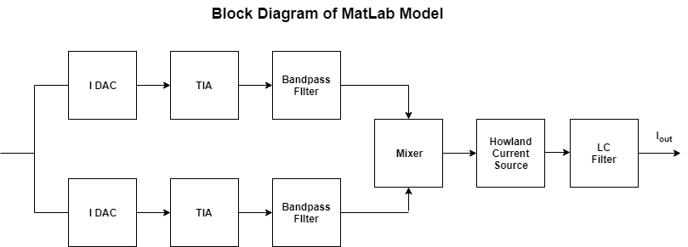

1. **Generation of Digital Sine Wave using the ADC function**

The purpose of the ADC function was to generate a digital sine wave which would model the input to the DAC. In order to produce a coherently sampled sine wave, it was necessary to satisfy the condition:

|  |  |  |
| --- | --- | --- |
|  | $$\frac{fs}{fi}=\frac{N}{m}$$ | (1) |

Where:

fs = sampling frequency (Hz)

fi = input frequency (Hz)

N = number of sample points

m = Number of cycles (prime number)

In the main script, m is calculated by finding the prime number nearest to the ratio given by the number of samples, the sampling frequency and the desired input frequency. The input frequency is then calculated using Equation (1) with this m value.

The ADC function input and output parameters are as follows:

|  |  |
| --- | --- |
| **MATLAB Input variable names** | **Input parameter** |
| Cycle_sample_ratio | Cycle-to-sample ratio (m/N) |
| Full_Scale | Full Scale (peak-to-peak amplitude) (A) |
| num_bits | DAC bit precision |
| NearestPrime | Nearest prime number of cycles |
| Phase_Shift | Phase shift |

|  |  |
| --- | --- |
| **MATLAB Output variable names** | **Output parameter** |
| DigitalOutput | Digital sine wave (A) |
| Normalised_Time | Normalised time vector (s) |
|  |  |
|  |  |
|  |  |

In the ADC function, the input signal period is normalised to 1 second; the record length is related to the number of samples (cycles). The time vector must be scaled by the input (or sampling) frequency in the main script to give the true time vector.

1. **Modelling the DAC Output**

It was decided that the ADI LTC1668 DAC would be used to convert the digital sine wave into an analog waveform. This DAC has 16-bit precision, 50MSPS and output-referred noise of 50pA/√Hz. As the quantisation noise of the DAC is inherently included in the ADC function, the sources of noise which needed to be modelled in the DAC function were thermal and 1/f noise. The DAC 1/f noise is modelled as:

|  |  |  |
| --- | --- | --- |
|  | $${PSD}_{Flicker}=\frac{k_{f}}{f}$$ | (2) |

The kf scaling factor is calculated by specifying the corner frequency at which the 1/f noise and thermal noise powers are equal, as in the figure below.

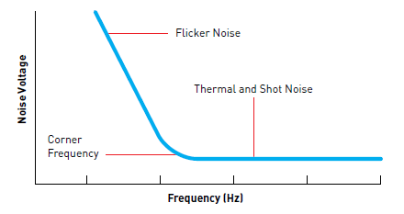

Figure 1, showing the frequency response of thermal and 1/f noise

The 1/f noise power is then calculated from the integral:

|  |  |  |
| --- | --- | --- |
|  | $$P_{Flicker}= \int_{Δf}^{fs/2}{PSD_{Flicker}\left(f\right)df}$$ | (3) |

Where $Δf$ is the width of the first bin in the FFT (= fs/N). The total 1/f noise power (variance) is then given by:

|  |  |  |
| --- | --- | --- |
|  | $$P_{Flicker}=f_{c}*{\left(\overline{i_{n,th}}\right)}^{2}*ln\left(\frac{N}{2}\right)$$ | (4) |

Where:

fc = corner frequency (Hz)

N = Number of sample points

$\overline{i_{n,th}}$ is expressed in A/√Hz

The DAC function input and output parameters are as follows:

|  |  |
| --- | --- |
| **MATLAB Input variable names** | **Input parameters** |
| FCornerDAC | DAC Corner frequency (Hz) |
| FullScale | Full scale (peak-to-peak) (A) |
| NearestPrime | Nearest prime number of cycles |
| num_bits | Bit precision |
| NumSamples | Number of sample points |
| TNoiseDAC | DAC Thermal Noise (A/√Hz) |
| fs | Sampling frequency (Hz) |
| Phase_Shift | Phase shift |

|  |  |
| --- | --- |
| **MATLAB Output variable names** | **Output parameters** |
| DAC_Output | Analog sine wave (A) |
| DAC_NormalisedTime | Normalised time vector (s) |
|  |  |
|  |  |
|  |  |
|  |  |
|  |  |

From section 4, we can see that the mixer stage requires a voltage input signal. In order to convert the DAC current output to a voltage, a TIA is used with a trans-impedance resistance of 1kΩ, as in the figure below (The DAC output is modelled with a current source in the figure). The AD797 op-amp was used in the model for this block. The output voltage of the op-amp, Vo, is then given by:

|  |  |  |
| --- | --- | --- |
|  | $$V_{o}= -IR+\sqrt{{\left(\overline{e_{n}}\right)}^{2}+4kTR}$$ | (5) |
|  |  |  |

Where $\overline{e_{n}}$ is the input referred Op-Amp voltage noise density in $V/\sqrt{Hz}$

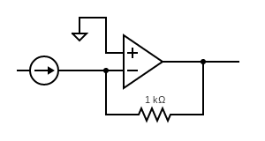

Figure 2, showing the current-to-voltage conversion using a TIA

The TIA function, which models this conversion, has input and output parameters as follows:

|  |  |
| --- | --- |
| **MATLAB Input variable names** | **Input parameters** |
| Signal | DAC Output (A) |
| Converter_R | Trans-impedance resistance (Ω) |
| Temperature | Temperature |
| Op_Amp_Noise | Op-amp output-referred noise density |

|  |  |
| --- | --- |
| **MATLAB Output variable names** | **Output parameters** |
| DAC_Output_v | DAC Output (V) |
|  |  |
|  |  |
|  |  |

1. **DAC RLC Filter**

In order to limit the amount of noise being introduced to the circuit during the filtering stage, a passive RLC was included in the model. The only source of thermal noise is due to the parasitic resistance of the inductor ( e.g. RP ≈ 50mΩ), and 1/f noise is not present as it is a passive filter. The filter transfer function and configuration are:

|  |  |
| --- | --- |
| $$\frac{V_{o}}{V_{in}}=\frac{\frac{1}{LC}}{s^{2}+\left(\frac{R_{p}}{L}\right)s+\frac{1}{LC}}$$ | (6) |
|  |  |

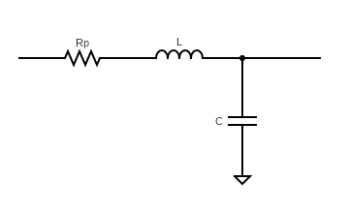

This filter (and any subsequent filtering stage) is implemented using the Filtering function. The Filtering function has input and output parameters as follows:

|  |  |
| --- | --- |
| **MATLAB Input variable names** | **Input parameters** |
| TFnum | Transfer function numerator coefficients* |
| TFden | Transfer function denominator coefficients* |
| Signal | Input signal |
| Time | Time vector (s) |
| FCornerFilter | Filter corner frequency (Hz) |
| TNoiseFilter | Filter Thermal Noise (V/√Hz) |
| fs | Sampling frequency (Hz) |
| IO_Refer | Noise Indicator (Input/Output referred noise) |

|  |  |
| --- | --- |
| **MATLAB Output variable names** | **Output parameters** |
| Filtered_Signal | Filtered signal |
|  |  |
|  |  |
|  |  |
|  |  |
|  |  |
|  |  |
|  |  |

*The transfer function numerator and denominator coefficients are specified as arrays in descending powers of s, e.g. s2 + 3s + 2 -> [1 3 2]

1. **Analog Multiplication**

The purpose of the analog multiplication stage is to reduce the effect of 1/f noise for low frequency signals by driving the DAC channels at a carrier frequency $ω_{0}$ offset by the desired stimulus frequency $Δω$. As can be seen in Equation 7, the product of these signals will create a signal at $2ω_{0}t+Δω$ and at $Δω$, allowing us to low pass filter the high frequency carrier $2ω_{0}$ signal, leaving a low noise, low frequency signal free of flicker noise (instead thermally noise limited).

|  |  |  |
| --- | --- | --- |
|  | $$\sin\left(ω_{0}t\right)\sin\left(\left(ω_{0}+∆ω\right)t\right)=\frac{1}{2} \left[\cos\left(∆ωt\right)-\cos\left(\left(2ω_{0}+ ∆w\right)t\right)\right]$$ | (7) |

For higher frequency signal inputs beyond the $\frac{1}{f}$ noise corner, the dual channel mixing may not be required, and a switch can be implemented to switch between dual-channel, low-pass filter mode and single-channel, band-pass filter mode.

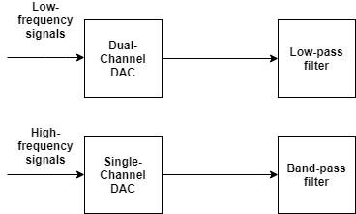

1. **Howland Current Source**

A Howland current source was used to convert the voltage signal chain to a current output. The idea of the Howland Current Source is to balance two resistor bridge feedback paths, governed by the condition:

|  |  |  |
| --- | --- | --- |
|  | $$Voltage Gain=G = \frac{R_{4}}{R_{3}}=\frac{R_{2A}+R_{2B}}{R_{1}}$$ | (8) |

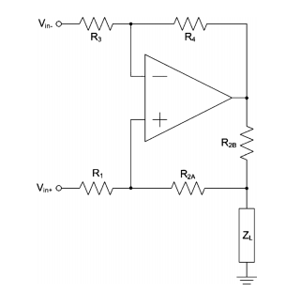

When this condition is satisfied, the Howland configuration can be modelled as a voltage-controlled current source (VCCS) with transconductance given by:

$$G_{m}=\frac{i_{out}}{V_{in}}=\frac{G}{R_{2B}}$$

The output-referred noise density of the Howland Current Source is given by:

|  |  |  |
| --- | --- | --- |
|  | $$i_{out}=\sqrt{4kTR_{x}+e_{n}^{2}{\left(\frac{R_{1}+R_{2}}{R_{1}R_{2B}}\right)}^{2}}$$ | (9) |

where

|  |  |  |
| --- | --- | --- |
|  | $$R_{x}=\frac{{\left(R_{2A}+R_{2B}\right)}^{2}}{R_{1}R_{2B}^{2}}+\frac{R_{4}^{2}}{R_{3}R_{2B}^{2}}+\frac{R_{2A}+R_{2B}+R_{4}}{R_{2B}^{2}}$$ | (10) |

The Howland Current Source was modelled with the AD797 op-amp. As the largest voltage output of the op-amp is 15V, in order to achieve a minimum output current of 100nA, R2B was set to $150MΩ$. By defining the gain, G, of the Howland model to be:

|  |  |  |
| --- | --- | --- |
|  | $$G=\frac{R_{4}}{R_{3}}$$ | (11) |

Equation 9 can be simplified to:

|  |  |  |
| --- | --- | --- |
|  | $$i_{out}=\frac{1}{R_{2B}}\sqrt{4kTG\left(R_{1}+R_{2A }+R_{2B}+R_{3}+R_{4}\right)+e_{n}^{2}{\left(1+G\right)}^{2}}$$ | (12) |

The non-idealities of the Howland Current Source which were modelled were the resistor mismatch due to the tolerances of the resistors, which can be modelled as an output impedance RO1, the finite gain of the op-amp which can be modelled as an output impedance RO2 and the finite bandwidth of the op-amp which is modelled as a capacitor (Co) which forms a pole with the $(R_{O1}|\left|R_{O2}\right)$, which are given by:

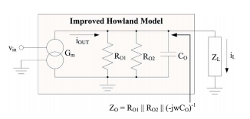

|  |  |  |
| --- | --- | --- |
|  | $$R_{O1}=\frac{R_{2B}\left(R_{1}+R_{2A}\right)}{ε(R_{2A}+R_{2B})}$$ | (13) |

|  |  |  |
| --- | --- | --- |
|  |  | (14) |

|  |  |  |
| --- | --- | --- |
|  |  | (15) |

Where:

AOL = Open-loop gain of the op-amp

GBWP = Gain-Bandwidth-Product of the op-amp (110MHz for the AD797)

ε = resistor mismatch error, given by:

|  |  |  |
| --- | --- | --- |
|  | $$ϵ=1-\frac{R_{1}R_{4}}{R_{2}R_{3}}$$ | (16) |

This model and optimization is derived based on the analysis performed in [1].

In order to minimise the output-referred current noise density, it is necessary to minimise G, R1, R2A, R3 and R4, while at the same time considering that R1, R2A and R3 must be sufficiently large in order to drive as much of the output current as possible into the load impedance.

1. **Current-Mode LC Filter**

The purpose of the current-mode LC filter is to filter out the noise generated by Howland Current Source. The filter transfer function is given by:

|  |  |  |
| --- | --- | --- |
|  | $$\frac{i_{o}}{i_{in}}=\frac{\left(\frac{1}{CZ_{L}}\right)s+\frac{R_{p}}{LCZ_{L}}}{s^{2}+\left(\frac{R_{p}}{L}+\frac{1}{CZ_{L}}\right)s+(\frac{1}{LC}+\frac{R_{p}}{LCZ_{L}})}$$ | (17) |

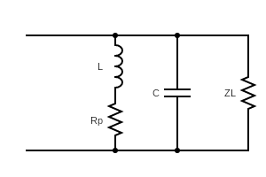

Where

Rp = Parasitic resistance of the inductor (Ω)

ZL = Load impedance (Ω)

C = Capacitance (F)

**References**

# [1] Biocompatible, High Precision, Wideband, Improved Howland Current Source with Lead-Lag Compensation, Aaron S. Tucker, Member, IEEE, Robert M. Fox, Senior Member, IEEE, and Rosalind J. Sadleir, Member, IEEE (<https://ieeexplore.ieee.org/stamp/stamp.jsp?tp=&arnumber=6221965>)

# [2] Spectrum analyzer with noise reduction by cross-correlation technique on two channels, M. Sampietro, L. Fasoli, and G. Ferrari (<https://aip.scitation.org/doi/pdf/10.1063/1.1149785?class=pdf>)